**Shri Vaishnav Vidyapeeth Vishwavidyalaya, Indore**

**Shri Vaishnav Institute of Information Technology**

**Department of computer science and engineering**



**PROJECT**

**B. Tech + MBA**

**Subject: Advanced Java Programming**

**Enrollment no.: 1810DMBCSE03313**

**Course Code: BTCS-409**

**2nd Year /4th semester**

**Submitted by Subject Teacher**

**Sanskar Bomb Mr. Sachin Chirgaiya**

**Objective:**

**A COVID-19** software where admin can issue E-pass to the citizens.

**Users of the System**

1. Admin
2. User

**Tools used**

1. Eclipse
2. MySQL
3. Apache Tomcat

**Database schema**

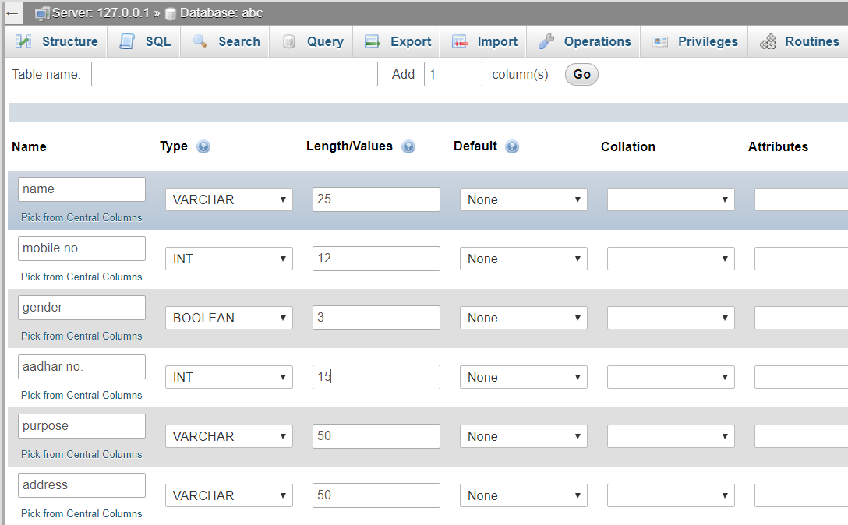

**Servlet classes:**

1. **HttpServlet:** provide functionality to implement HTTP requests.
2. **HttpSessionEvent:** Apache Tomcat.
3. **CitizenServlet.java:** to process HTTP req.

**Other classe:**

1. **Dao class**: For connecting to MySQL.

**Major challenges:**

One of the majar challenge is to verify the citizen and other challenge is to MySQL connection.

How to take photo proof of the applicant is another challenge.

**Front look of the registration form:**

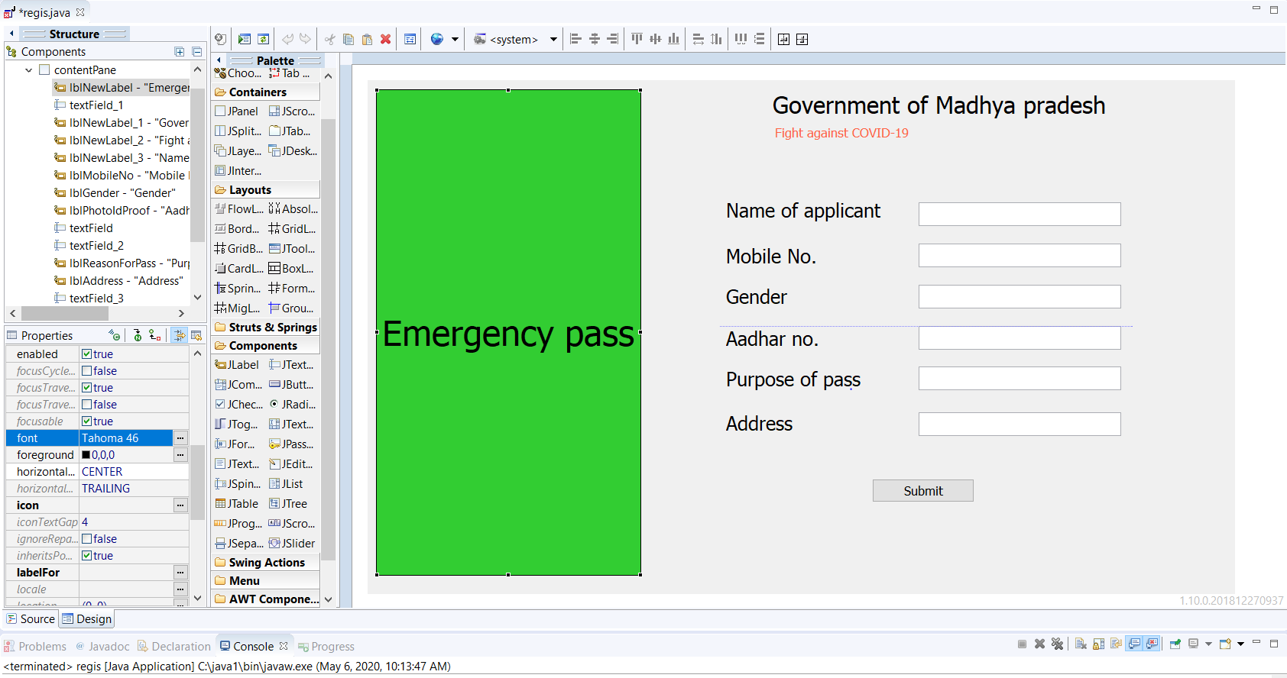

Algorithm:

1. First data is collected through website.
2. Data is stored in database.
3. Now admin has to verify the data.
4. After verification E-pass admin has to generate the pass.
5. Pass is uploaded to the specific ID so that it can be download.